Give a real-world example that requires sorting or a real-world example that requires computing a convex hull.
A real-world example of sorting is pretty straightforward - for example, every web page that renders a list alphabetically needs to sort the entries - a catalog, an index or whatever.
I have no clue why we need to compute convex hulls, but Wikipedia says that there are a bunch of applications.
Other than speed, what other measures of efficiency might one use in a real-world setting?
Memory usage and resource utilization (network, database) are good answers.
Select a data structure that you have seen previously, and discuss its strengths and limitations.
Let's take the singly-linked list.
Strengths:
- It does not need sequential space in memory
- We can insert a new element at any place
Limitations:
- Random access is $\mathcal{O}(n)$
- It takes additional memory for the links
How are the shortest-path and traveling-salesman problems given above similar? How are they different?
They are similar, because each of then has to walk a graph and find a path in them.
The difference is the constraint on the solution. The shortest-path requires just a path between two points, while the traveling salesman requires a path between more points that returns to the first point.
Come up with a real-world problem in which only the best solution will do. Then come up with one in which a solution that is "approximately" the best is good enough.
Sorting a catalog is a problem, where only the best solution will do. An "approximately" sorted catalog won't be that useful.
Finding the shortest path between two points in a city is a problem, where good-enough will do. It might not be the fastest way, but you will still get there.
Suppose we are comparing implementations of insetion sort and merge sort on the same machine. For inputs of size $n$, insertion sort runs in $ 8n^{2} $ steps, while merge sort runs in $ 64n\lg{n} $ steps. For which values of $n$ does insertion sort beat merge sort?
At $ n > 43 $ merge sort beats insertion sort.
What is the smallest value of $n$ such that an algorithm whose running time is $ 100n^{2} $ runs faster than an algorithm whose running time is $ 2^{n} $ on the same machine?
At $ n > 14 $, the first algorithm runs faster.
Using figure 2.4 as a model, illustrate the operations of Insertion-Sort on the array $ A = \langle 31, 41, 59, 26, 41, 58 \rangle $.

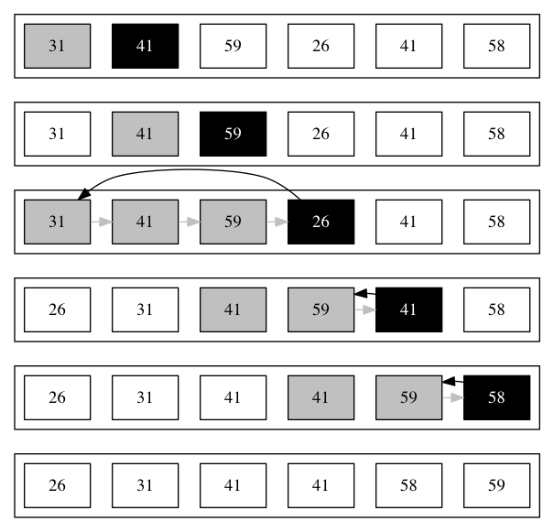

Rewrite the Insertion-Sort procedure to sort into nonincreasing instead of nondecreasing order.
The only thing we need to do, is flip the comparison:
for j = 2 to A.length
key = A[j]
i = j - 1
while i > 0 and A[i] < key
A[i + 1] = A[i]
i = i - 1
A[i + 1] = key
Using Figure 2.4 as a model, illustrate the operation of merge sort on the array $A = \langle 3, 41, 52, 26, 38, 57, 9, 49 \rangle$.

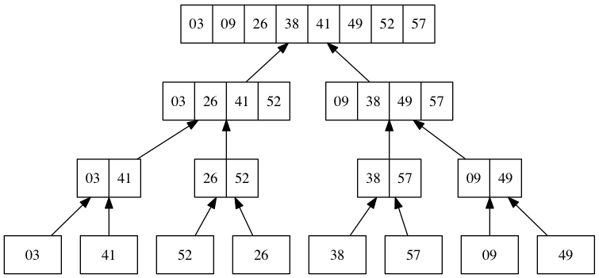

Rewrite the MERGE procedure so that it does not use sentinels, instead stopping once either array L or R has had all its elements copied back to A and then copying the remainder of the other array back into A.

MERGE(A, p, q, r)
n1 = q - p + 1
n2 = r - q
let L[1..n₁] and R[1..n₂] be new arrays
for i = 1 to n₁
L[i] = A[p + i - 1]
for j = 1 to n₂
R[j] = A[q + j]
i = 1
j = 1
for k = p to r
if i > n₁
A[k] = R[j]
j = j + 1
else if j > n₂
A[k] = L[i]
i = i + 1
else if L[i] ≤ R[j]
A[k] = L[i]
i = i + 1
else
A[k] = R[j]
j = j + 1

What are the minimum and maximum numbers of elements in a heap of height $h$?
It is between $2^n$ and $2^{n+1} - 1$. For example, a heap with $2$ ($2^1$) or $3$ ($2^2 - 1$) will have height $1$. If there are four elements, however, the heap height will be $2$.

Show that in any subtree of a max-heap, the root of the subtree contains the largest value occuring anywhere in the subtree.
This follows from the max-heap property.
If the $i$th element is the root of the subtree, then both its children would be less or equal to it. Since this properties holds for their children too and it is transitive, all of the descendents will be less or equal to the root, making it the largest value.

Where in a max-heap might the smallest element reside, assuming that all elements are distinct?
In any of the leaves, that is, elements with index $\lfloor n/2 \rfloor + 1$ (see exercise 6.1-7), that is, in the second half of the heap array.
Using figure 6.2 as a model, illustrate the operation of MAX-HEAPIFY(A, 3) on the array $A = \langle 27, 17, 3, 16, 13, 10, 1, 5, 7, 12, 4, 8, 9, 0 \rangle$.
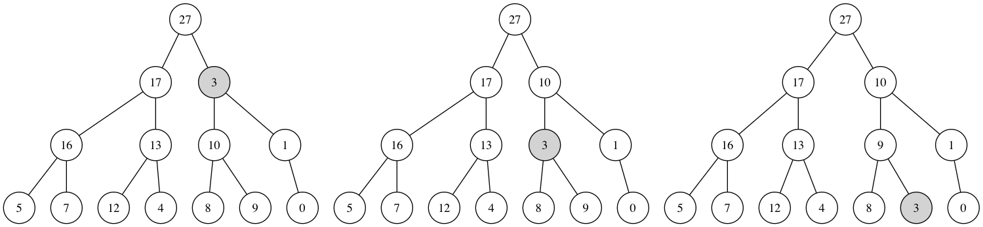
Starting with the procedure MAX-HEAPIFY, write pseudocode for the procedure MIN-HEAPIFY(A, i), which performs the corresponding manipulation on a min-heap. How does the running time of MIN-HEAPIFY compare to that of MAX-HEAPIFY?
MIN-HEAPIFY(A, i)
l = LEFT(i)
r = RIGHT(i)
if l ≤ A.heap-size and A[l] < A[i]
smallest = l
else
smallest = i
if r ≤ A.heap-size and A[r] < A[i]
smallest = r
if smallest ≠ i
exchange A[i] with A[smallest]
MIN-HEAPIFY(A, smallest)
The running time is the same. Actually, the algorithm is the same with the exceptions of two comparisons and some names.
What is the effect of calling MAX-HEAPIFY(A, i) when th element $A[i]$ is larger than its children?
No effect. The comparisons are carried out, $A[i]$ is found to be largest and the procedure just returns.
What is the effect of calling MAX-HEAPIFY(A, i) for $i > A.heap-size / 2$?
No effect. In that case, it is a leaf. Both LEFT and RIGHT return values that fail the comparison with the heap size and i is stored in largest. Afterwards the procedure just returns
Using figure 6.3 as a model, illustrate the operation of BUILD-MAX-HEAP on the array $A = \langle 5, 3, 17, 10, 84, 19, 6, 22, 9 \rangle$.
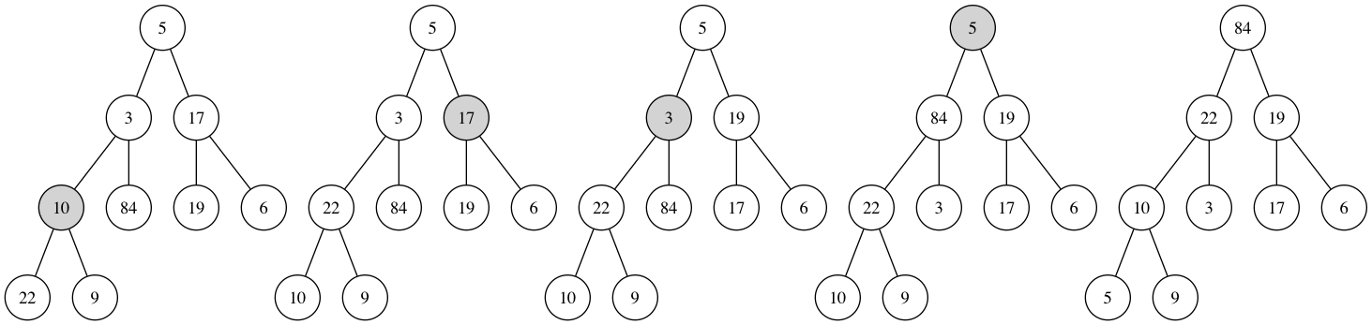
Using figure 6.4 as a model, illustrate the operation of HEAPSORT on the array $A = \langle 5, 13, 2, 25, 7, 17, 20, 8, 4 \rangle$.

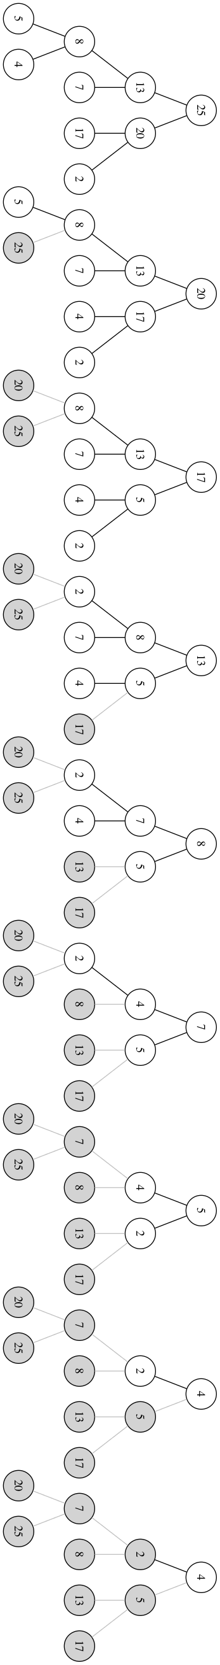

Illustrate the operation HEAP-EXTRACT-MAX on the heap $A = \langle 15, 13, 9, 5, 12, 8, 7, 4, 0, 6, 2, 1 \rangle$.
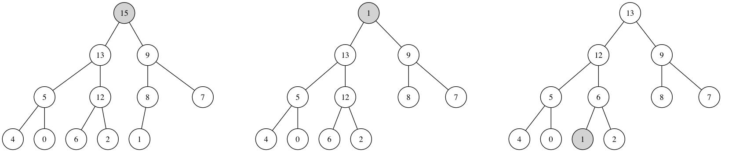
Illustrate the operation of MAX-HEAP-INSERT(A, 10) on the heap $A = \langle 15, 13, 9, 5, 12, 8, 7, 4, 0, 6, 2, 1 \rangle$.

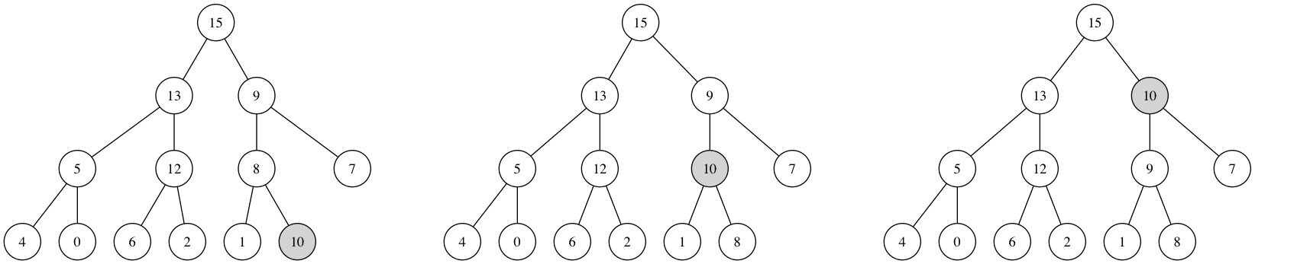

Write pseudocode for the procedures HEAP-MINIMUM, HEAP-EXTRACT-MIN, HEAP-DECREASE-KEY, and MIN-HEAP-INSERT that implement a min-priority queue with a min-heap.

The operation HEAP-DELETE(A,i) deletes the item in node $i$ from heap $A$. Give an implementation of HEAP-DELETE that runs in $\O(\lg{n})$ time for an $n$-element max-heap.
HEAP-DELETE(A, i):
A[i] = A[A.heap-size]
A.heap-size -= 1
MAX-HEAPIFY(A, i)

Using figure 7.1 as a model, illustrate the operation of PARTITION on the array $A = \langle 13, 19, 9, 5, 12, 8, 7, 4, 21, 2, 6, 11 \rangle$.

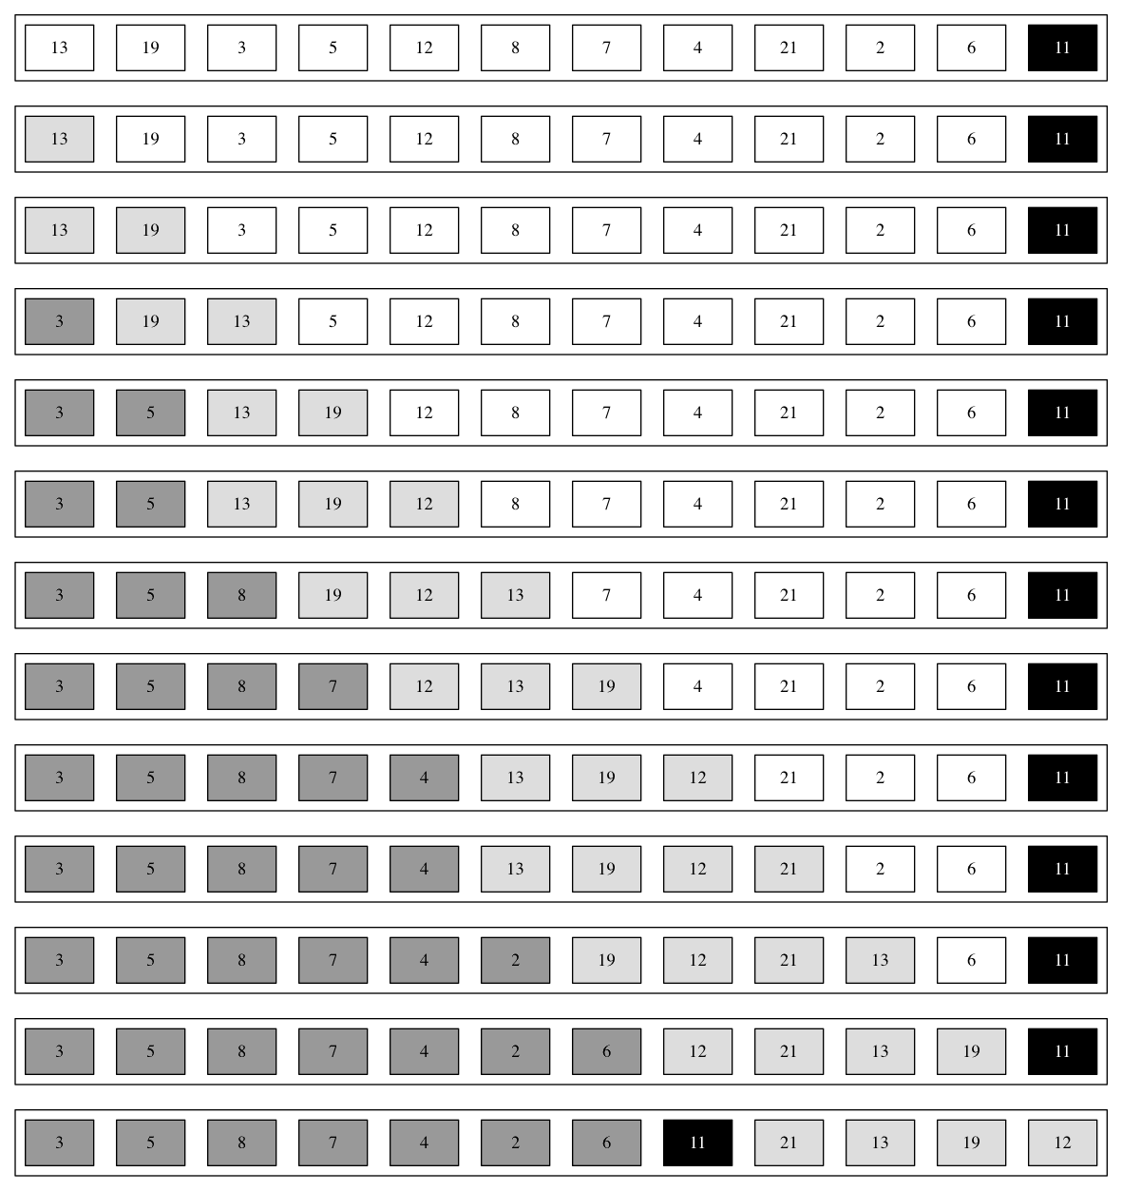

How would you modify QUICKSORT to sort into nonincreasing order?
We only need to flip the condition on line 4.
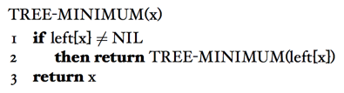
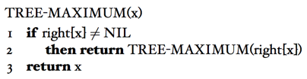

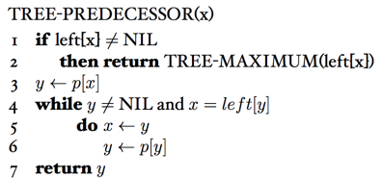

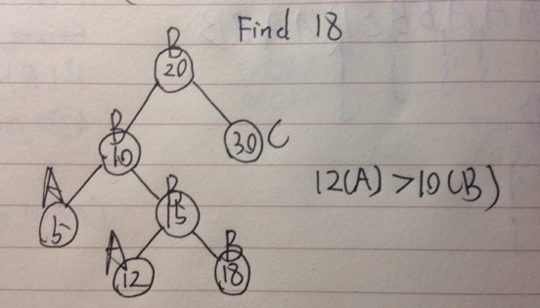
Professor Bunyan thinks he has discovered a remarkable property of binary search trees. Suppose that the search for key k in a binary search tree ends up in a leaf. Consider three sets: A, the keys to the left of the search path; B, the keys on the search path; and C, the keys to the right of the search path. Professor Bunyan claims that any three keys a∈A, b∈B, and c∈C must satisfy a ≤ b ≤ c. Give a smallest possible counterexample to the professor’s claim.

Is the operation of deletion "commutative" in the sense that deleting x and then y from a binary search tree leaves the same tree as deleting y and then x? Argue why it is or give a counterexample.

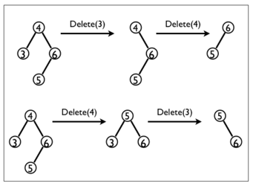

Give a dynamic-programming solution to the 0–1 knapsack problem that runs in O(n W) time, where n is number of items and W is the maximum weight of items that the thief can put in his knapsack.

Answer
DYNAMIC-0-1-KNAPSACK(v,w,n,W)
for w <- 0 to W do
c[0,w] <- 0
end for
for i <- 1 to n do
c[i,0] <- 0
for w <- 1 to W do
if wi <= w then
if vi+c[i-1,w-wi] > c[i-1,w] then
c[i,w] <- vi + c[i-1,w-wi]
else
c[i,w] <- c[i-1,w]
end if
else
c[i,w] <- c[i-1,w]
end if
end for
end for
return c[n,W]
What is an optimal Huffman code for the following set of frequencies, based on the first 8 Fibonacci numbers?
a:1 b:1 c:2 d:3 e:5 f:8 g:13 h:21
Can you generalize your answer to find the optimal code when the frequencies are the first n Fibonacci numbers?
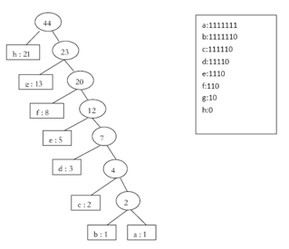

Give an adjacency-list representation for a complete binary tree on 7 vertices. Give an equivalent adjacency-matrix representation. Assume that vertices are numbered from 1 to 7 as in a binary heap.

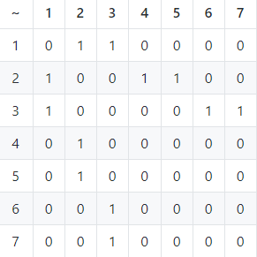

Make a 3-by-3 chart with row and column labels WHITE, GRAY, and BLACK. In each cell (i, j), indicate whether, at any point during a depth-first search of a directed graph, there can be an edge from a vertex of color i to a vertex of color j. For each possible edge, indicate what edge types it can be. Make a second such chart for depth-first search of an undirected graph.

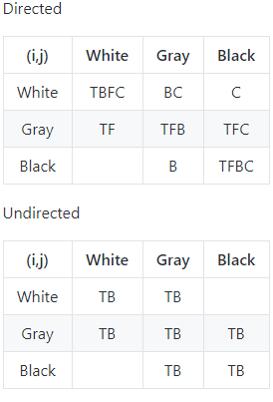

Show how depth-first search works on the graph of Figure 22.6. Assume that the for loop of lines 5-7 of the DFS procedure considers the vertices in alphabetical order, and assume that each adjacency list is ordered alphabetically. Show the discovery and finishing times for each vertex, and show the classification of each edge.

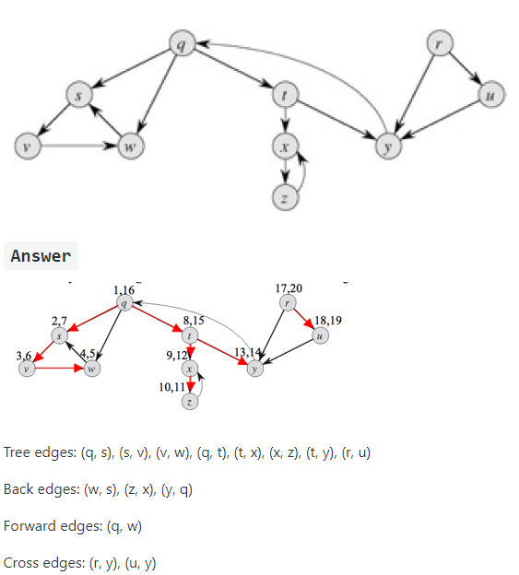

Rewrite the procedure DFS, using a stack to eliminate recursion.

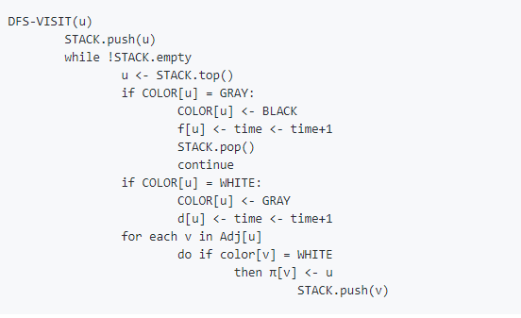

Give a counterexample to the conjecture that if there is a path from u to v in a directed graph G, then any depth-first search must result in d[v] < f[u].

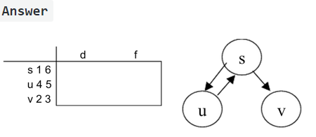

Suppose that the graph G = (V, E) is represented as an adjacency matrix. Give a simple implementation of Prim's algorithm for this case that runs in O(V^2) time.

MST-PRIM(G, w, r)
for each u ∈ V[G]
do key[u] <- ∞
π[u] <- NIL
key[r] <- 0
Q <- V[G]
while !isEmpty(Q)
do u <- EXTRACT-MIN(Q)
for i <- 1 to n
do if MATRIX[u][i] == 1 and i ∈ Q and w(u,i) < key[i]
then π[i] <- u
key[i] <- w(u, i)
Run the Bellman-Ford algorithm on the directed graph of Figure 24.4, using vertex z as the source. In each pass, relax edges in the same order as in the figure, and show the d and π values after each pass. Now, change the weight of edge (z, x) to 4 and run the algorithm again, using s as the source.

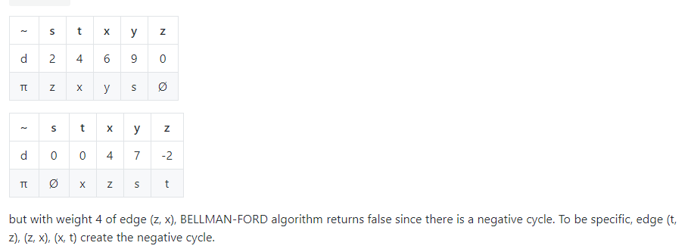
Modify the Bellman-Ford algorithm so that it sets d[v] to -∞ for all vertices v for which there is a negative-weight cycle on some path from the source to v.
Bellman-Ford-New(G, w, s)
Initialize-Single-Source(G, s)
for i <- 1 to |V[G]| - 1
do for each edge (u,v) ∈ E[G]
do Relax[u, v, w]
for each edge (u, v) ∈ E[G]
do if d[v] > d[u] + w(u, v)
d[v] = -∞
for each v such that d[v] = -∞
do Follow-And-Mark-Pred(v)

Follow-And-Mark-Pred(v)
if π[v] != nil and d[π[v]] != -∞
do d[π[v]] = -∞
Follow-And-Mark-Pred(π[v])
else
return

Run Dijkstra's algorithm on the directed graph of Figure 24.2, first using vertex s as the source and then using vertex z as the source. In the style of Figure 24.6, show the d and π values and the vertices in set S after each iteration of the while loop.

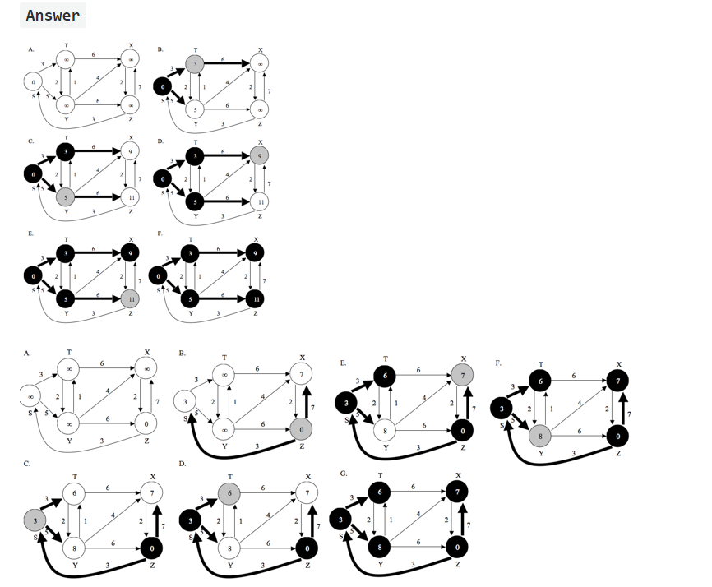
Prove that the fractional knapsack problem exhibits the greedy choice property:

We want to show that the fractional knapsack problem has the property that a choice that yields a local optimum also gives a global optimum. Let I be the following instance of the knapsack problem: Let n be the number of items, let v(sub)i be the value of the i’th item, let wi be the weight of the i’th item and let W be the capacity. Assume the items have been ordered in increasing order by vi/wi and that W ≥ wn. Let s = (s1, s2, . . . , sn) be a solution. The greedy algorithm works by assigning sn = min(wn, W), and then continuing by solving the subproblem I 0= (n−1, {v1, v2, . . . , vn−1}, {w1, w2, . . . , wn−1}, W −wn) until it either reaches the state W = 0 or n = 0. We need to show that this strategy always gives an optimal solution. We prove this by contradiction. Suppose the optimal solution to I is s1, s2, . . . , sn, where sn < min(wn, W). Let i be the smallest number such that si > 0. By decreasing si to max(0, W − wn) and increasing sn by the same amount, we get a better solution. Since this a contradiction the assumption must be false. Hence the problem has the greedy-choice property.

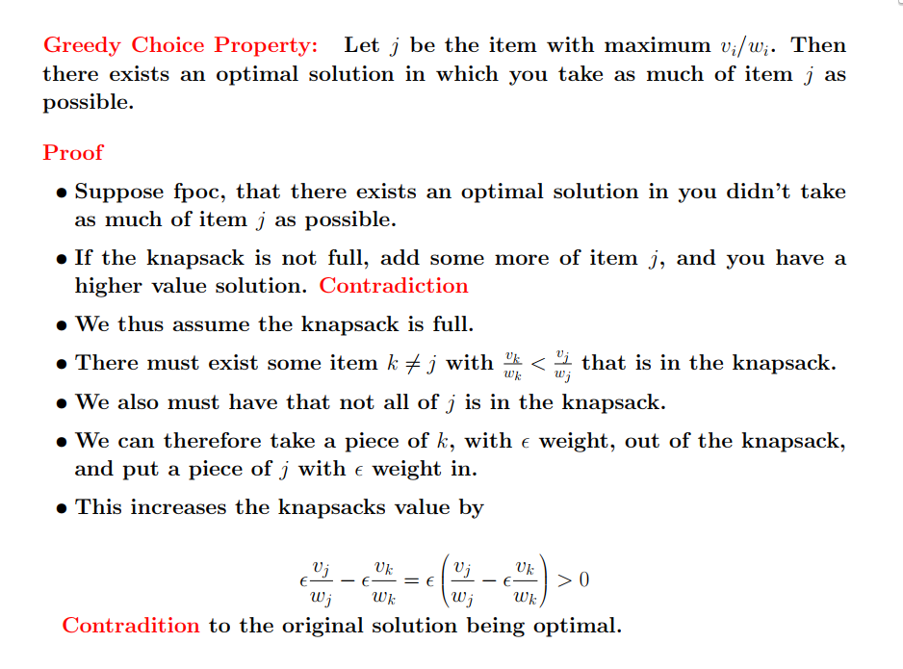
Show the execution of the Edmonds-Karp algorithm on the flow network of Figure 26.1(a).
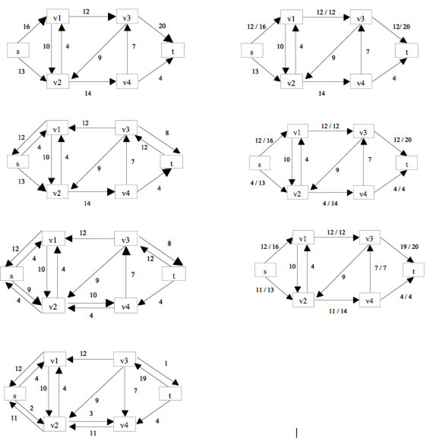
Run the Ford-Fulkerson algorithm on the flow network in Figure 26.8(b) and show the residual network after each flow augmentation. Number the vertices in L top to bottom from 1 to 5 and in R top to bottom from 6 to 9. For each iteration, pick the augmenting path that is lexicographically smallest.
